Review Day
Working with your Trio/Buddy:
- Discuss: If you were a kitchen utensil, what would you be and why?
- Reflection: In what ways have you adapted your communication style to better connect with your group members?
- Explore: create the schema for an instagram clone. Think about what the data is and how you would save it - think about normalization - how will you keep your DB from saving duplicate information?
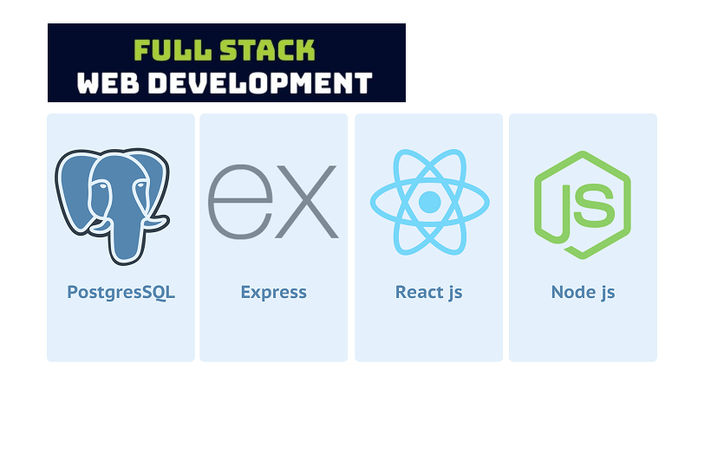

Identify and fill the gaps
You have done incredible things these last 6 milestones. As you combine all these skills, spend this milestone reflecting on the fact that you’ve already become a full-stack software engineer. You’ve learned a LOT—especially the last milestone. Surely there’s a topic or two you wished you had more time to absorb. That’s what today and tomorrow should be about. Thoughtfully and restfully determine where you need more work and apply yourself to that as you start to think about this milestone’s weather project.

- Review your introductory React concepts
  - Why React?
  - What is JSX and how is it different from HTML?
  - There are syntactic differences between HTML and JSX
  - Which function renders your webpage?
  - Where in the HTML does the React component render?
  - Once you declare a React component, how do you use it? What is the syntax?
  - What are some useful React hooks and their purpose?
  - Why should you use Vite to set up your React app?
  - Describe how the React hierarchy works.
  - Creating React components and filling them with dynamic data.
  - Using callback functions to pass data from a child to parent component
  - Understand state and props
  - 7 React Lessons I Wish I Knew Earlier
- Express + APIs
  - Creating Express routes
  - Connecting data between Express and React
  - Showing data from an API call
- CSS. Have you really practiced/tried all the different CSS topics? Have you saved them to a bookmark folder so you can easily refer back to them? Have you thought about what you might try this week?
- SQL. Can you write a query? Have you gotten familiar with Postico?
- How has your participation in code challenges been? If you feel quiet or unsure during code challenges, this is a great day to do 1-2 of them alone, or find a partner.
- How’s your personal pitch and soft-skills practice coming?

Milestone Project: Weather App
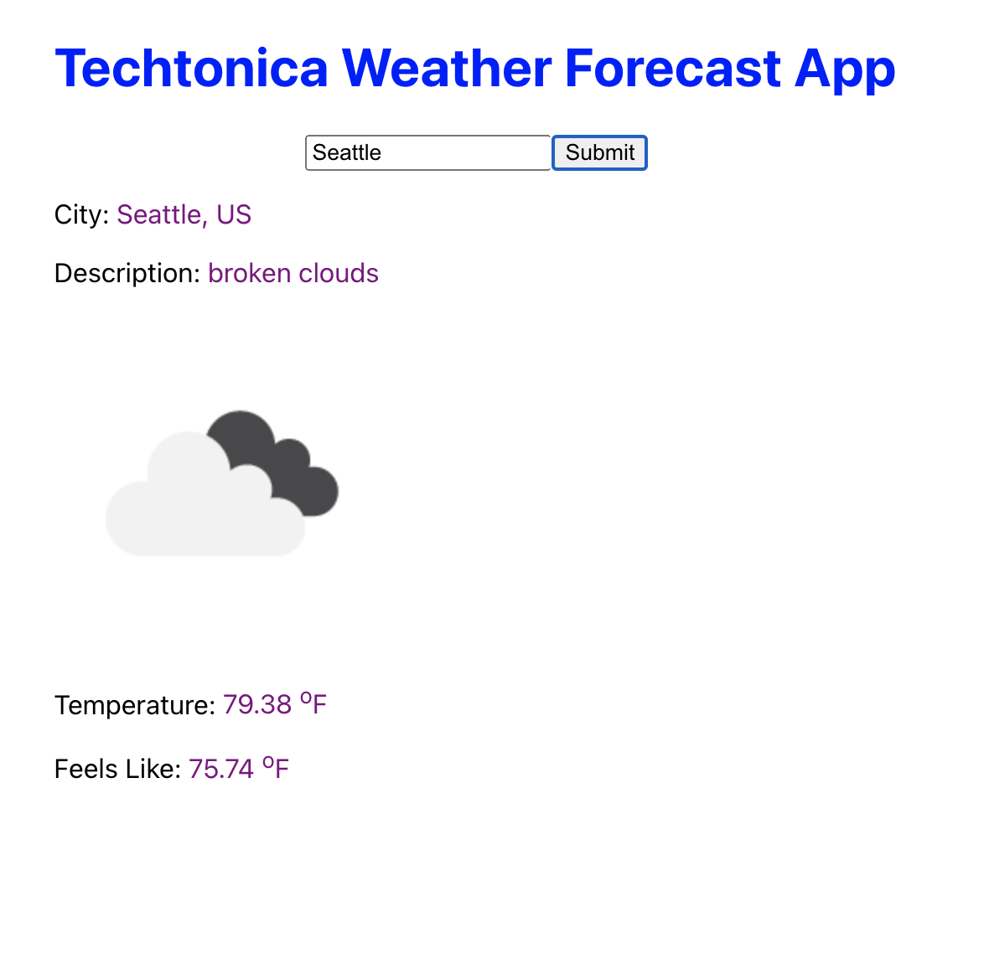
It’s recommended to make sure you have your student API access setup with OpenWeatherMapAPI and watch Postman + OpenWeatherAPI with Volunteer Anthony). NOTE: OpenWeatherMap has many different endpoints. We think the easiest one to use is this one, However this is a slightly older version (this is 2.5 and they have moved onto 3+).
- Try accessing your data via postman
- Try putting that request into your project code from the last milestone - do you remember how to call from an API?!?

Order of things to make sure you understand for this milestone’s project
- Creating a GET request in postman to retrieve data
- Creating an app with Express and React
- Using a hardcoded URL Documentation (https://api.openweathermap.org/data/2.5/weather?q={city name}&appid={API key}) to create a route in Express which returns the data to the React Frontend
- Show weather data object in the front end (returned raw data)
- Show styled weather data in the front end (make the data look pretty)
- Before working on styling and calling your API a million times try hard coding an example response into a file in Express and use that data instead of a live call
- EXTRA BONUS: If you get all this done, then you can create a form to ask a user for their city to make a dynamic API request

Open Source Activity: By now, you should be a full fledged contributor to the open source project you selected during the last milestone. This milestone you need to find your first issue to work on and submit a PR resolving the issue selected. This issue should be contributing towards the progress or development of the OS project and not simply adding your name or a single grammatical fix. Be sure to not leave this for the last minute, as you still may need support from existing collaborators for getting your repo set up, having historical context about the issue, or even time to look through existing or previous PRs and issues. During your project share, you will also show this PR in response to an issue.

EOD questions:
- I would like you to take some time today and really think about if you know what each part of the stack is doing. It is SO EASY to focus on the steps of implementation and not the much more important - WHY. Remember you will use many different technologies in your careers, understanding what each part it doing will you help you translate to the next.
- During wrap up I would like you to all be prepared to bring 1 question you have about WHY and HOW these technologies work and work together. Let’s fill those gaps!!

